

Brake, Owen

Couch

2017-05-23

GLC20R-I

Computer Scientist

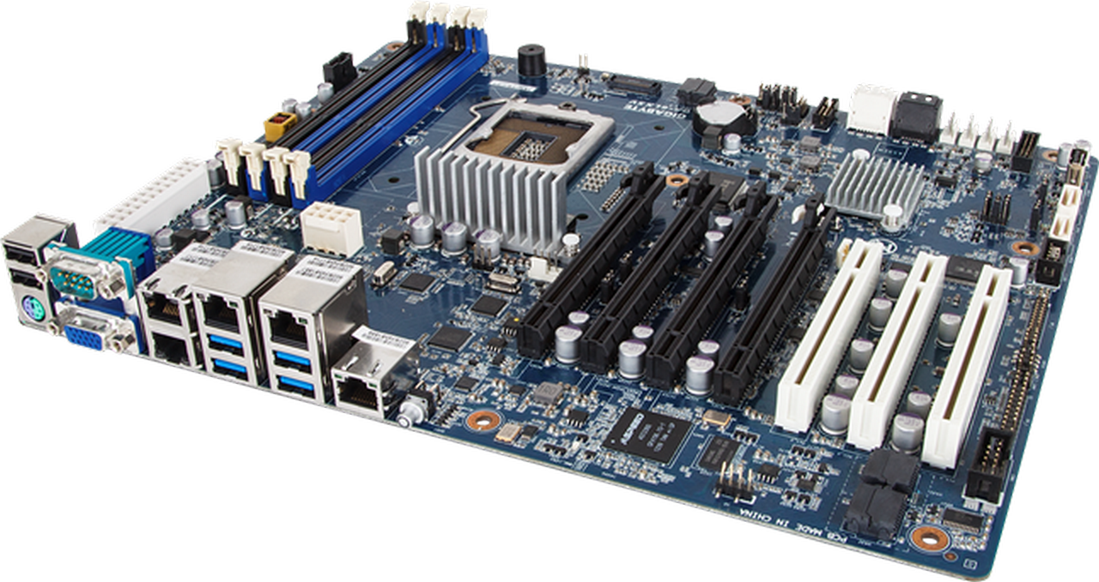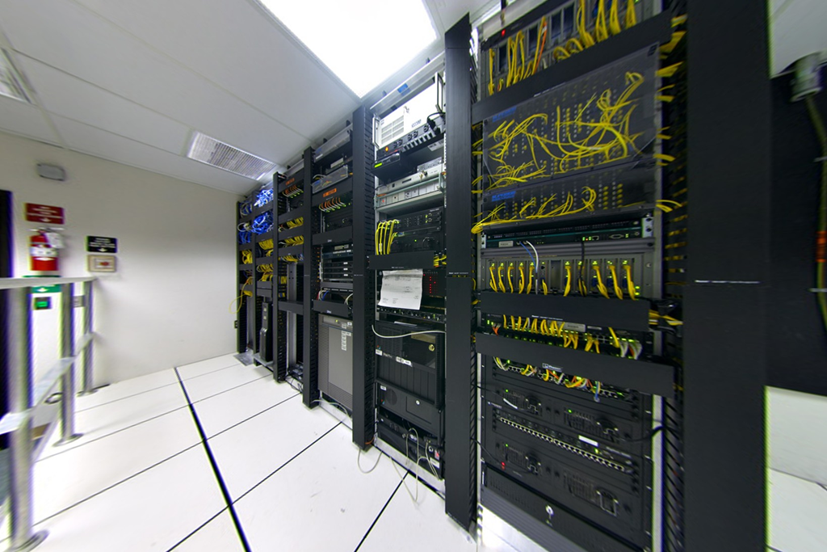

**Table of Contents**

Introduction and Description 1

Career Opportunities 2

Fundamental Skills Required for Employment 3

Life in the Workplace? 3

Educational Requirements 5

Salary Expectations 7

What’s the Outlook? 9

Similar Occupations 10

Contacts 11

Conclusion 12

References 14

# Introduction and Description

Computer Science is the study of the theory and application of the principles of computing. This field deals with the software side of computing over the hardware often practiced in computer engineering or electrical engineering. The subject spans from mathematical algorithms and theories to the creation of practical applications. Computer Science has evolved over the centuries from its humble beginnings as the abacus to the tiny modern microchip. It has and remains to be a fantastic occupation, as it becomes more prevalent in today’s society the need for Computer Science students has grown exponentially. With so many career choice after obtaining a Computer Science degree it allow students to do what they enjoy and excel at. However becoming a Computer Science student is not easy, students require advanced knowledge in mathematics and years of experience before being considered for a job. Computer Science is an occupation for certain people, those who excel in working with computers, math and science however it is not for every person, many succeed because they have a passion for this field however many do not because they cannot handle the load of a computer scientist.

# Career Opportunities

There are many career opportunities for Computer Science graduates that cover all the aspects of computing. The most common application of Computer Science is through programming where developers must apply their theoretical knowledge to create a working program these employees are known as Computer Programmers. However many computer scientists do not program and apply their skills in other areas. A Software Quality Assurance tester will identify problems in programs and track issues in a database for programmers to fix. A Network Systems Administrator is responsible for installing than maintaining­ server architecture and optimizing networks. Theoretical computer scientists plan out the theory of complex programs before they are programmed by the Computer programmers, these employees are often used in big tech firms to optimize applications and create complex algorithms. There is finally the professors, professors teach the principles of computing to students from as little as elementary school to post-secondary education. Becoming a professor is a great career, University professors do not work over the summer, receive fantastic pay and benefits and have the opportunity to teach their passion. There are so many more careers that Computer Science students can take and with all of these options students are guaranteed to find one which suits them.

Figure 2 Network Systems Administrator

Figure 1 Computer Programmer

# Fundamental Skills Required for Employment

Computer Scientists require years of experience before they can work in the field and with that experience require certain fundamental skills. Every computer scientist has to be able to analyze and solve problems to work, programmers have to fix bugs, Quality assurance has to find these bugs, and every career requires problem solving skills. Computer scientists also need to be logical, programming is pure logic just giving a computer instructions a programmer has to be logical if they hope to succeed. Mathematics is a very important part of Computer Science every part from programming to theory requires math, the basic building blocks of computing, binary requires math if any computer scientist wants to pursue this occupation they require a deep understanding of mathematics. Working well under stress is required for the Computer Science field, programmers live under immense stress with employers expecting the best quality of work programmers have to work plenty of overtime and nights to complete a job that is satisfactory for an employer. Finally however the most important skill is being knowledgeable in the field, degrees do not really matter what really matters is if an employee has experience, the employee must have the experience required for employment often 4 years of experience to be considered.

# Life in the Workplace?

The life of a computer scientist is one of hard labor however the payoff can be rewarding. The most common careers for Computer Science graduates is that of programmers. The field of programming is vast and covers many different areas however the majority of programmers will be working in a company in which they receive a steady salary. Programmers will be tasked with programming and up keeping applications for a business. Programmers often spend 8 - 10 hours a day, a standard 40 hour work week however programmers will often do lots of overtime. Programmers will do a lot of overtime because they are pressured to finish assignments, employers often underestimate the length of time needed for completion which results in employees having to do overtime to complete a task in time. Workers will often wear business casual attire, not very professional clothing however clothing that is still appropriate for work. Depending on the size of a business employees may work with a team of 10 or a 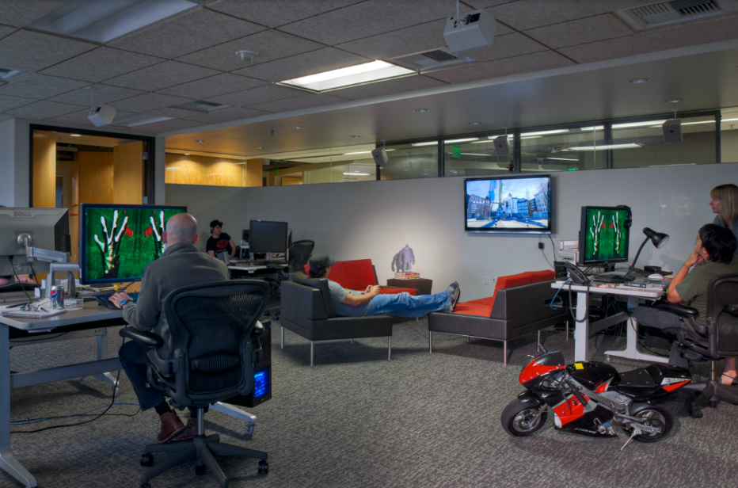team of 1000 however programmers will always be working as a team, so employees are required to have team working abilities and be able to communicate well with others. Since programming requires a team employees often do not work in cubicles which is a major advantage for some people, employees will often work in large open spaces since they are required to communicate with each other to complete tasks. Employees work in these large open spaces and it is a 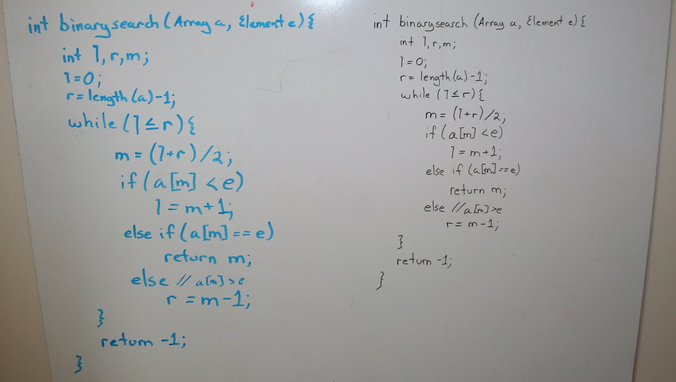misconception that programmers stare at a computer for 8 hours a day however this is mostly false, programmers do work with computers a lot but most of the time is actually working with a team figuring out ways to solve an issue on paper. Programmers write out on a white board (refer to Figure 4.) different ways to complete a task, figuring out how to solve problems and at the end programmers will type it all in, a large part of a programmers job is spent solving problems not as is thought typing endlessly into a computer. Despite all of the time spent away from computers, programmers will need to know how to code and will have to spend at least 2 hours every day on the computer typing in code. Overall Computer Science is a great occupation for some people and depending on the type of person they may love the work environment or they may hate it with a passion.

Figure 3 Example open workspace at Valve

Figure 4 Example whiteboard used in a programming office

# Educational Requirements

The journey for entering the field of Computer Science begins in high school where students must decide their future. To get into Computer Science the best post-secondary option is a university this is because university provides the theory knowledge and there is so much theory in Computer Science, also universities have the reputation which is important for getting jobs. In high school, students have the option of taking Computer Technology in grade 10 this is the first class students can take if they are interested in computers. Computer Tech teaches students how to work with circuitry, the basic principles of computers such as binary and hexadecimal most importantly though Computer technology teaches students programming in python which is highly important for any students going into Computer Science. However Computer Technology is not required to go into Computer Science for most universities, most universities require Computer Science grade 11 or Computer Science grade 12. Computer Science teaches students more about programming and the principles of computing. Computer Science students learn languages such as assembly which teaches students the most basic principles of computing which is a great skill for programmers before going into university. The University of Waterloo says that under its requirements for Computer Science that “Grade 11 U Introduction to Computer Science” is recommended but not required for admission according to (Computer Science admission requirements for Ontario high school students, n.d.). However “Advanced Functions 4U Calculus” and “Vectors 4U” are required in most universities for Computer Science according to (Computer Science admission requirements for Ontario high school students, n.d.) due to their requirement for many Computer Science fields. The Computer Science field is not extremely difficult to get into one just needs to choose the right courses and get an average in the 80s however to get into a prestigious university or co-op one would need to get averages in the mid-90s to be considered.

The best post-secondary option for Computer Science is university. University provides theory knowledge which makes up the majority of the Computer Science field. At university the best option is to earn a bachelor of Computer Science because it will set up a student for the workforce due to its prestige. Computer Science at university is a very difficult occupation, there is steep competition however the reward is tremendous. It is near impossible to enter the Computer Science field without a 4 year bachelor’s degree, the field has high standard for employment and even a college degree will get you a low end job. At University students can expect to take lots of mathematics classes including calculus and algebra and students will take many Computer Science courses. A student can also at some universities go in to the co-op program. At the co-op program students will receive the practical knowledge along with the theoretical knowledge and the prestige that comes with the degree. If a student enters the co-op program than the student will work at a workplace for a certain amount of months to graduate. The best universities for Computer Science in Canada are the University of Waterloo (Figure 6.), the University of Toronto (Figure 5.) and the University of British Columbia (Figure 7.). However all universities are very similar and the most important part is getting a Computer Science bachelor’s degree, that is what really matters to employers they care about the degree.

Figure 6 University of Waterloo

Figure 7 University of British Columbia

Figure 5 University of Toronto

# Salary Expectations

Computer Science is an occupation with a high demand and therefore has a high salary compared to other similar occupations. According to (Computer Programmer Salary Canada, n.d.) the median salary for a computer programmer in Toronto, Ontario is $ 35.10 an hour, the entry level wage is $21.63 an hour and a peak wage is $53.00 an hour. These are quite high considering the average hourly wage in April 2017 for full time employees was 27.95 according 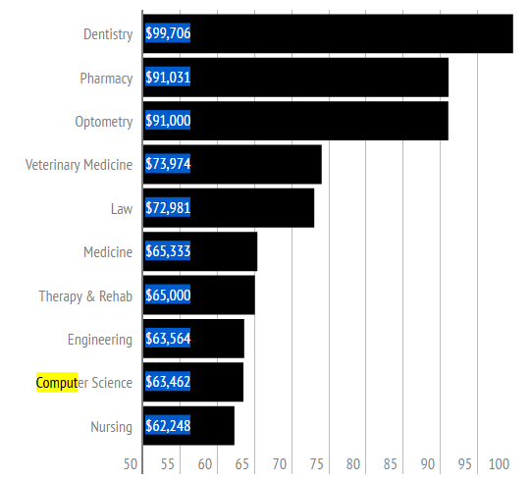to (Average hourly wages of employees by selected characteristics and occupation, unadjusted data, by province (monthly), 2017) this would mean that a programmer has a $7.15 more per hour than the average worker. It is also important to note that the Computer Science field is vast that is why the entry level salary is more than half that of the peak wage, the peak would probably be executives at companies while the entry level would probably be employees just above intern level. As can be seen in Figure 8. Computer Science is in the top 10 highest paying jobs for university graduates at “$63,462” which is great for employees considering the average for graduates in 2011 was “49,398” according to (Dehaas, 2014). Computer Science graduates also have a 96.5% to have a job after graduating from university which is quite high according to (Dehaas, 2014). All of these statistics are important and sound amazing however success is not guaranteed, the randomness of life means anything can happen, one may get a fantastic $100,000 salary or maybe get a lower $20,000-35,000 salary. Stress is also an important factor, many employees cannot handle the field and choose to pursue another path due to the difficulty of Computer Science and the pressure put on by employers to create inhuman tasks.

Figure 8 Statistics representing the average salary for computer science graduates. Retrieved from (Dehaas, 2014)

# What’s the Outlook?

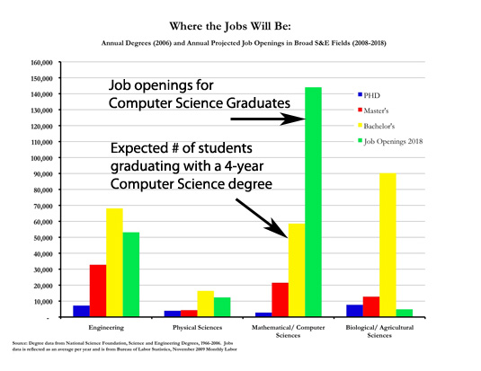The future for Computer Science jobs looks good, the combination of high demand met with the lack of students is breeding a deficiency of jobs therefore there is a higher demand and salary. This trend of increasing demand for computer scientists is not meeting the number of employees. However employers require a lot from employees, employers have high expectations therefore it is a stressful business. One of the reasons the salary is so high as well is that the employers expect an application with certain requirements but do not understand the technical limitations and issues with creating it so it requires the best employees to create the program. Despite all of this as one can see in Figure 9 there are ~145,000 Computer Science job openings expected for 2018 however the number of bachelor degrees expected in 2018 is ~59,000 that means for every Computer Science graduate they have 2.5 jobs that are unfilled for them. This is incredible for employees considering that the lower supply of eligible employees the higher the demand and supply for them. It is safe to say that eventually with the heavy emphasis on Science, Technology, Engineering and Mathematics education the market will balance itself with more graduates however for the near future it is a fantastic idea to get into Computer Science or anything related to computing.

Figure 9 the job opening projected for computer science graduates in 2018 compared to the projected graduates from bachelor’s degree, master’s degree and PHD. Retrieved from (Job Market and Oppurtunities, n.d.)

# Similar Occupations

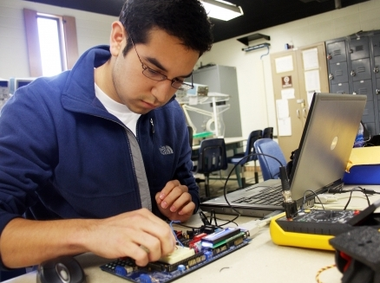 There are many degrees that are very similar to Computer Science and many overlap, this gives students an opportunity to choose a degree that is tailored to their abilities. One such degree in electrical engineering, in electrical engineering students study the application of electricity often working with circuits and wiring real world objects to create a machine. Computer Science and electrical engineering are similar, they both often deal with computing and electronics however electrical engineering differs it deals with more of the real world application and often create the boards that are required for computer scientists to work on in the virtual world. Another similar degree is that of computer engineering, this degree blends the hardware of electrical engineering with the software of Computer Science. This degree work with the virtual side of the equation and the real world application, students will work with wiring alongside software and networking. The degree creates a blend so students do not focus all their energy on one side they are versatile which is great for employability. What is required for all of these degree is a background in mathematics, every computing field requires at least some background in mathematics. A degree in mathematics is an option for those interested in computing however cannot get a degree in one, mathematics is extremely important in the Computer Science field since it deals with the creation of algorithms, graphing of results and thinking logically. All of these degrees are similar to Computer Science however Computer Science is unique, it teaches students the intricacies of computing and software which cannot be found in any other degree

Figure 11 Computer Engineer

Figure 12 Mathematician

Figure 10 Electrical Engineer

# Contacts

One of the methods to getting into computer science is getting into a university for computer science. To apply to a university applicants should go to the Ontario Universities’ Application Centre or OUAC website at <https://www.ouac.on.ca/>. The OUAC processes applications for university applicants and is one of the only ways students can apply to universities in Ontario. However the Royal military college of Canada does not process through OUAC and can instead be applied through their own website at https://www.rmcc-cmrc.ca/en/registrars-office/apply-now. If for any reason an applicant cannot apply online for OUAC they may contact them on the phone at 519-823-1064 for application related inquires or 519-823-1940 for non-application inquires. The address for OUAC’s headquarters is 170 Research Lane, Guelph, Ontario and their postal code is N1G 5E2, they are open Monday to Friday between 8:30am and 4:30pm Eastern Standard Time.

The first step to entering university for Computer Science is discovering which university to apply to. One of the ways to finding this out is by going to the Ontario Universities’ Fair. At this fair there will be booths of many representatives from universities who will help explain the different programs each school offers and give the information to potential applicants. The Ontario Universities’ Fair is being held at the Metro Convention Centre on 222 Bremner Boulevard, Toronto. The fair will occur between September 22,2017 and September 24,2017 between the times of 10am to 5pm. More information can be found by emailing the fair at ouf@ouac.ca.

Another option instead of university is a coding boot camp, where students will the principles of computing and how to program. A programming boot camp is a great starting point for people looking to enter into computer science and to let people know whether this is the field they would really like to enter into. One of the best boot camps in Canada is “le Wagon” which runs out of 17 different cities around the world including in Canada. Le wagon is based in Montreal at 5333, Casgrain avenue and the postal code is H2T1X3. The boot camp can be applied online at their website <https://www.lewagon.com/montrea>l by calling Marie-Gabrielle at +1 514-458-3448 or by emailing Marie-Gabrielle at [montreal@lewagon.org](mailto:montreal@lewagon.org). The course is 9 weeks long and is a great choice for people who want to enter into the field computer science or those who need the knowledge to start a business for themselves.

The final part of entering computer science is finding a job. Jobs are always a difficult things to find however with modern technology they are becoming easier and easier to find. A great website to find jobs is Workopolis.com, employees can search by their job title and location to find a job which suits them. Employees are able to access employers from across the country without leaving their house. More information can be found by emailing [jobseekersupport@workopolis.com](mailto:jobseekersupport@workopolis.com), entering an inquiry form at <http://www.workopolis.com/shared/en/contactus/seeker> or by mailing a letter to the headquarters at 1 Yonge Street, Suite 402, Toronto, Ontario with the postal code M5E 1E6.

# Conclusion

Computer Science is a fantastic occupation for those who are interested in math, computers and science. Computer Science deals with many different areas math in creating algorithms, computers is the basis of the occupation learning how they work and programming and science learning how electron flow through circuits and the physics of computing. Those who excel in these fields should consider entering the field of Computer Science. Now that computers have become so prevalent in today’s society the need for those who can work with them has grown incredibly since they are now in phones, televisions, personal computers and watches, society depend on computers. As the most common career path after graduating with a bachelor of Computer Science or a BCS programmers will be tasked with creating and maintaining applications for different devices. However programming is not the only option and many computer scientists choose to do other careers that suit their abilities and desires, some graduates do not like building applications and may choose to become a Network Systems Administrator or Computer Security expert. The occupation of Computer Science is so large that any person interested in computing can find a career that they enjoy. Computer Science is an occupation that is growing steadily and right now is the time for students to enter the field with great salaries, good work environments and many great career choices which are tailored to people’s abilities a student cannot go wrong with choosing Computer Science.

# References

*Average hourly wages of employees by selected characteristics and occupation, unadjusted data, by province (monthly)*. (2017, May 5). Retrieved from Statistics Canada: http://www.statcan.gc.ca/tables-tableaux/sum-som/l01/cst01/labr69a-eng.htm

*Computer Programmer Salary Canada*. (n.d.). Retrieved from Living in Canada: http://www.livingin-canada.com/salaries-for-computer-programmers-canada.html

*Computer Science admission requirements for Ontario high school students*. (n.d.). Retrieved from University of Waterloo: https://uwaterloo.ca/find-out-more/admissions/admission-requirements/computer-science/canada/ontario/

Dehaas, J. (2014, September 5). *Salary survey shows some university graduates earn far more*. Retrieved from CTV News: http://www.ctvnews.ca/canada/salary-survey-shows-some-university-graduates-earn-far-more-1.1992755

*Do Computer Programmers Work Long Hours?* (n.d.). Retrieved from Computer Science Degree Hub: http://www.computersciencedegreehub.com/faq/computer-programmers-work-long-hours/

*Job Market and Oppurtunities*. (n.d.). Retrieved from University of Western Science: https://www.csd.uwo.ca/prospective_students/undergraduate_students/job_market_and_opportunities.html